Form 435-1

GSSD GENERAL EVALUATION REPORT

Employee | Insert Name
Current Role | Insert Title
Department | Insert Department
Date of Report | Click or tap here to enter text.

Type of Evaluation – Check one

☐ 1 Year Final Probationary ☐ Annual Review (4 years)

☐ Interim Probationary (3 & 6 months) ☐ Other_____________________

Purpose - To ensure follow through of service commitments
- To provide accurate appraisal documentation to protect both the employer and the employee
- To ensure the will of the Board of Education is met with respect to foundational statements
- To build self-efficacy and demonstrate the employee’s impact on GSSD Strategic Plan

Cycle of Supervision for Central Office – GSSD has employed a four-year cycle involving conversations, products, and observations
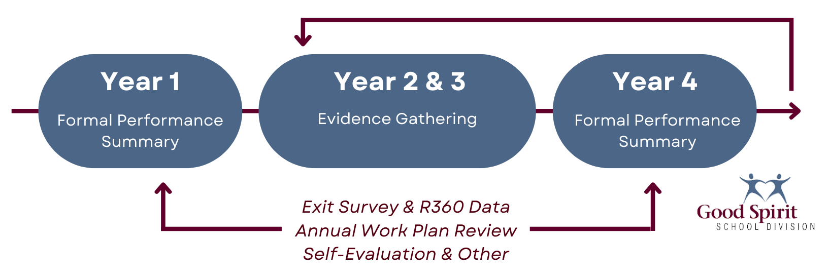

Work History - Employee writes their own bio as an introduction

Education & Recent Professional Development - Employee documents their own educational background, qualifications and professional development opportunities

Personal Information – Employee provides background information on their family, hobbies, interests, etc.

Mark (X) the box that most accurately reflects your evaluation of the employee.

4. Exemplary: A person who continually exceeds requirements and expectations; work can be a model for other school divisions,

3. Proficient A person who consistently meets requirements and expectations; one who excels in one or more areas of performance.

2. Progressing: A person who inconsistently meets the requirements and expectations; one who has areas of performance that require improvement.

1. Not Meeting Expectations: A person whose performance is notably below job requirements and expectations; significant improvement to performance is required.

Not Applicable The criteria is not applicable to the position

Part 1 - Criteria for Evaluation
Mark an (X) in the box that most accurately reflects your evaluation of the employee.
4. Exemplary | 3. Meets Expectations | 2. Progressing | 1. Not Meeting Expectations | 4 | 3 | 2 | 1 | N/A
Quality of Work
- Completes work with the expected degree of quality.  - Is attentive to detail, and actively seeks out and corrects issues.  - Able to arrive at sound solutions, even in unusual circumstances.  - Work is consistently complete and accurate. |  |  |  | ☐ | ☐ | ☐ | ☐ | ☐
 |  |  |  | ☐ | ☐ | ☐ | ☐ | ☐
 |  |  |  | ☐ | ☐ | ☐ | ☐ | ☐
 |  |  |  | ☐ | ☐ | ☐ | ☐ | ☐
Comments: |  |  | Growth Areas:
4. Exemplary | 3. Meets Expectations | 2. Progressing | 1. Not Meeting Expectations | 4 | 3 | 2 | 1 | N/A
Organization of Work
- Organizes day well.  - Plans work in advance.  - Manages time and conflicting priorities.  - Completes assignments within expected timeframe. |  |  |  | ☐ | ☐ | ☐ | ☐ | ☐
 |  |  |  | ☐ | ☐ | ☐ | ☐ | ☐
 |  |  |  | ☐ | ☐ | ☐ | ☐ | ☐
 |  |  |  | ☐ | ☐ | ☐ | ☐ | ☐
Comments: |  |  | Growth Areas:

4. Exemplary | 3. Meets Expectations | 2. Progressing | 1. Not Meeting Expectations | 4 | 3 | 2 | 1 | N/A
Adaptability and Flexibility
- Learns new tasks easily.  - Responds well to changing needs and procedures.  - Accepts new ideas with relative ease.  - Suggests new methods and approaches to work. |  |  |  | ☐ | ☐ | ☐ | ☐ | ☐
 |  |  |  | ☐ | ☐ | ☐ | ☐ | ☐
 |  |  |  | ☐ | ☐ | ☐ | ☐ | ☐
 |  |  |  | ☐ | ☐ | ☐ | ☐ | ☐
Comments: |  |  | Growth Areas:
4. Exemplary | 3. Meets Expectations | 2. Progressing | 1. Not Meeting Expectations | 4 | 3 | 2 | 1 | N/A
Job Knowledge
- Fulfills the duties of the position.  - Has necessary skills to do the required job.  - Seeks further knowledge and professional development opportunities. |  |  |  | ☐ | ☐ | ☐ | ☐ | ☐
 |  |  |  | ☐ | ☐ | ☐ | ☐ | ☐
 |  |  |  | ☐ | ☐ | ☐ | ☐ | ☐
Comments: |  |  | Growth Areas:
4. Exemplary | 3. Meets Expectations | 2. Progressing | 1. Not Meeting Expectations | 4 | 3 | 2 | 1 | N/A
Communication Skills
- Conveys detailed information well.  - Communicates clearly and effectively within assigned role.  - Is clear and concise, both orally and in writing.  - Clarifies instructions when necessary.  - Shares knowledge and ideas.  - Listens well and responds appropriately. |  |  |  | ☐ | ☐ | ☐ | ☐ | ☐
 |  |  |  | ☐ | ☐ | ☐ | ☐ | ☐
 |  |  |  | ☐ | ☐ | ☐ | ☐ | ☐
 |  |  |  | ☐ | ☐ | ☐ | ☐ | ☐
 |  |  |  | ☐ | ☐ | ☐ | ☐ | ☐
 |  |  |  | ☐ | ☐ | ☐ | ☐ | ☐
Comments: |  |  | Growth Areas:
4. Exemplary | 3. Meets Expectations | 2. Progressing | 1. Not Meeting Expectations | 4 | 3 | 2 | 1 | N/A
Respect, Belonging and Learning
- Respectful of students and staff, agreeable and pleasant to all.  - Works well as part of a team and contributes to team effort.  - Agreeable to supervision.  - Eager to be helpful, creates a safe learning atmosphere.  - Quick to offer assistance and support, willing to share and learn from one another. |  |  |  | ☐ | ☐ | ☐ | ☐ | ☐
 |  |  |  | ☐ | ☐ | ☐ | ☐ | ☐
 |  |  |  | ☐ | ☐ | ☐ | ☐ | ☐
 |  |  |  | ☐ | ☐ | ☐ | ☐ | ☐
 |  |  |  | ☐ | ☐ | ☐ | ☐ | ☐
Comments: |  |  | Growth Areas:

4. Exemplary | 3. Meets Expectations | 2. Progressing | 1. Not Meeting Expectations | 4 | 3 | 2 | 1 | N/A
Attitude
- Demonstrates a positive attitude towards others, work, and school/division. |  |  |  | ☐ | ☐ | ☐ | ☐ | ☐
Comments: |  |  | Growth Areas:
4. Exemplary | 3. Meets Expectations | 2. Progressing | 1. Not Meeting Expectations | 4 | 3 | 2 | 1 | N/A
Responsibility
- Follows through on commitments and job duties consistently.  - Accepts accountability for his/her work.  - Properly follows instructions, directives, and procedures. |  |  |  | ☐ | ☐ | ☐ | ☐ | ☐
 |  |  |  | ☐ | ☐ | ☐ | ☐ | ☐
 |  |  |  | ☐ | ☐ | ☐ | ☐ | ☐
Comments: |  |  | Growth Areas:
4. Exemplary | 3. Meets Expectations | 2. Progressing | 1. Not Meeting Expectations | 4 | 3 | 2 | 1 | N/A
Nurture and Initiative
- Actively seeks out additional responsibilities, without being asked.  - Demonstrates an ability to encourage and/or inspire others by promoting intellectual, physical, emotional and spiritual well-being. |  |  |  | ☐ | ☐ | ☐ | ☐ | ☐
 |  |  |  | ☐ | ☐ | ☐ | ☐ | ☐
Comments: |  |  | Growth Areas:
4. Exemplary | 3. Meets Expectations | 2. Progressing | 1. Not Meeting Expectations | 4 | 3 | 2 | 1 | N/A
Attendance and Punctuality
- Regularly in attendance and is punctual.  - Uses time constructively. |  |  |  | ☐ | ☐ | ☐ | ☐ | ☐
 |  |  |  | ☐ | ☐ | ☐ | ☐ | ☐
Comments: |  |  | Growth Areas:

4. Exemplary | 3. Meets Expectations | 2. Progressing | 1. Not Meeting Expectations | 4 | 3 | 2 | 1 | N/A
Cooperation
- Agreeable and pleasant.  - Works well as part of a team.  - Agreeable to supervision.  - Eager to be helpful.  - Quick to offer assistance and support. |  |  |  | ☐ | ☐ | ☐ | ☐ | ☐
 |  |  |  | ☐ | ☐ | ☐ | ☐ | ☐
 |  |  |  | ☐ | ☐ | ☐ | ☐ | ☐
 |  |  |  | ☐ | ☐ | ☐ | ☐ | ☐
 |  |  |  | ☐ | ☐ | ☐ | ☐ | ☐
Comments: |  |  | Growth Areas:

Part 2
Provide this section to the employee to complete prior to the performance review and discuss the responses during the performance review.

Self-Reflections – Feedback for Supervisor
Question | Response
What was your greatest personal/professional celebration?
What was your greatest “team” celebration?
What was your greatest “team” disappointment/frustration?
What was your greatest “personal/professional” disappointment?
What can your supervisor do to make your job easier?
What does your supervisor currently do that makes your job more difficult?
What is an area of growth for you?
If you had the power to change “one” thing in GSSD, what would it be?
What drives you? Choose one or two and explain.
What do you want to be known for? What is your hope for your legacy?
What is one promise you are willing to make this year?

Part 3
Summary Comments
☐ Employee Achieved Performance Expectations ☐ Alter Probationary Date to: _____
☐ Terminate Probationary Employment ☐ Performance Improvement Plan
I have read the above report and discussed it with my supervisor. My signature does not indicate that I agree with the contents of the report. In accordance with GSSD Administrative Procedures, I understand that I have fourteen (14) days following this review to submit a written rebuttal if I feel this document inaccurate or unfair.
Signatures  (The supervisor should SAVE to PDF when complete and request digital signatures.) |  | Date
Employee’s Signature
Supervisor’s Signature

